44.
a) Ne, jer se koeficijenti smjera razlikuju.
b) Je, jer su koeficijenti smjera jednaki.
c) Je, jer su koeficijenti smjera jednaki.
d) 4y=8x+12 /:4
y = 2x+3 Je, jer su koeficijenti smjera jednaki.

45.
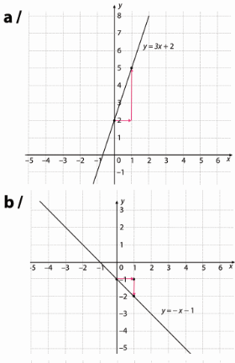
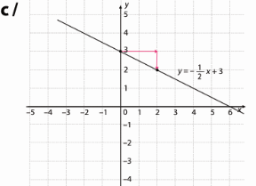
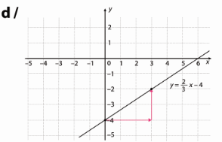
46.
a) y = x A(0,7) a=1, b=7
$y=x+7$

b) y = - x +4 a = -1, b = 7
$y=-x+7$

c) y = - ½ x +2 a = -1/2, b = 7
$y=-\frac{1}{2}x+7$

d) y = - 0.2x -0.6 a = -0.2, b = 7
$y=-0.2x+7$

47.
$$3x-2y=4$$
$2y=3x-4$ /:2
$y=\frac{3}{2}x-2$
$y=\frac{3}{2}x+b$
a)M(2,-2)
$-2=\frac{3}{2}∙2+b$
$b=-2-3=-5$
$y=\frac{3}{2}x-5$

b) M(3,0)
$0=\frac{3}{2}∙3+b$
$b=-\frac{9}{2}$
$y=\frac{3}{2}x-\frac{9}{2}$

c) P(-4,5)
$5=\frac{3}{2}∙(-4)+b$
$b=5+6=11$
$y=\frac{3}{2}x+11$

d) R(1,1)
$1=\frac{3}{2}∙1+b$
$b=1-\frac{3}{2}=-\frac{1}{2}$
$y=\frac{3}{2}x-\frac{1}{2}$

48.
a) 2
b) 1
c) 3

49.
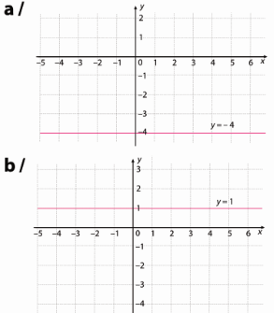
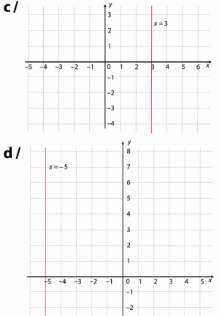

50.
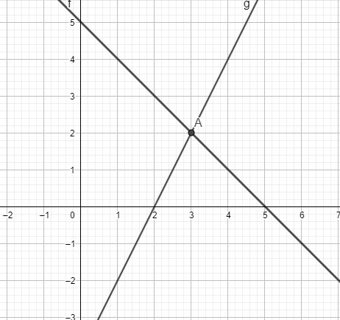
a)

Sjecište je A(3,2).
b)
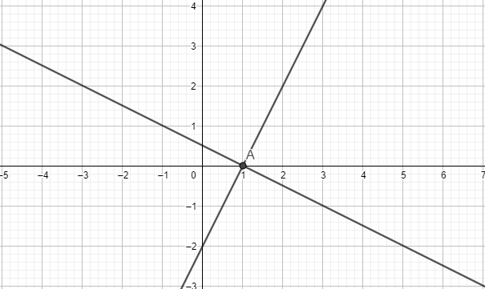
Sjecište je A(1,0).
51.
a) $2x-4y-5=0$
$4y=2x-5$
$y=\frac{1}{2}x-\frac{5}{4}$
$2y=4x-5$
$y=2x-\frac{5}{2}$
Nisu.

b) $y=-x+2$
$y=-x$
Jesu.

c) $y=-0.22x+2.2$
$y=-0.22$
Nisu.

52.
a) $y=-\frac{2}{3}x$
T(-6,2)
$2=-\frac{2}{3}∙(-6)+b$
$b=2-4=-2$
$y=-\frac{2}{3}x-2$

b) $y=-0.5x-16$
T(-6,2)
$2=-0.5∙(-6)+b$
$b=2-3=-1$
$y=-0.5x-1$

c) $y=\frac{3}{2}x+\frac{1}{2}$
T(-6,2)
$2=\frac{3}{2}∙(-6)+b$
$b=2+9=11$
$y=\frac{3}{2}x+11$

d) $y=-x$
T(-6,2)
$2=-6+b$
$b=2+6=8$
$y=-x+8$

e) $y=-\frac{1}{4}x+2$
T(-6,2)
$2=-\frac{1}{4}∙(-6)+b$
$b=2-\frac{3}{2}=\frac{1}{2}$
$y=-\frac{1}{4}x+\frac{1}{2}$

f) $y=2x$
T(-6,2)
$2=2∙(-6)+b$
$b=2+12=14$
$y=2x+14$

53.
a) y = 9
b) x = -17

54.
y = -1.5

55.
a) y = 2.5
b) x = -7

56.
a)
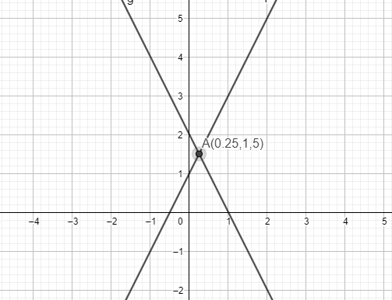

b)
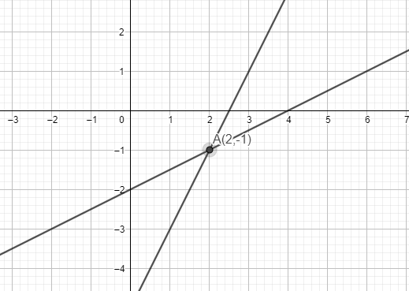
c)
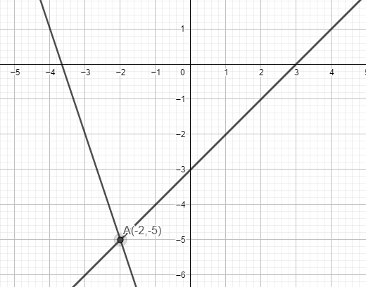

d)
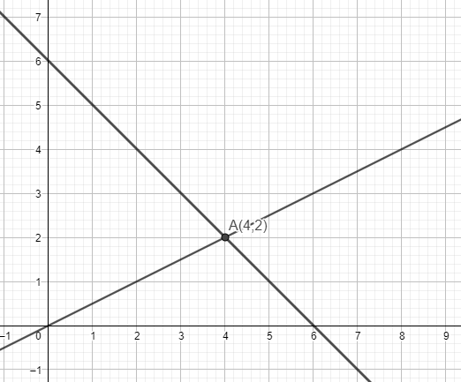
57.
a) Ne.
b) Da.
c) Ne.

58.
a) x=2
b) y=3

59. a)
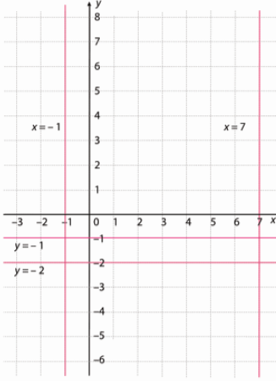
b)
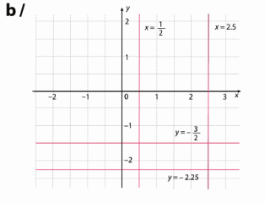
60.
a) karte 3·550=1650 kn
ostane 3000 – 1650 = 1350 kn
1350 : 90 = 15 dana
b) y – novac, x - dani
y = 3000 – 90x – 1650 = -90x +1350
c)
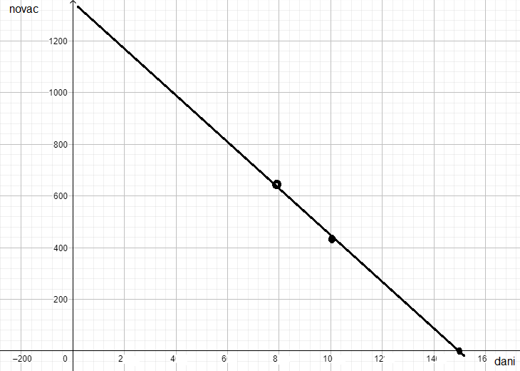
d) x = 8
y = -90·8+1350 = 630 kn
e) 450 = -90x +1350
90x =1350 – 450
90x=900
x =10

61.
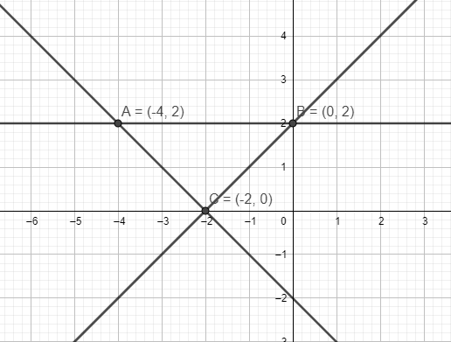
$P=\frac{|AB|∙v_{AB}}{2}=\frac{4∙2}{2}=4$ kvadratne jedinične dužine

